SINGAPORE

[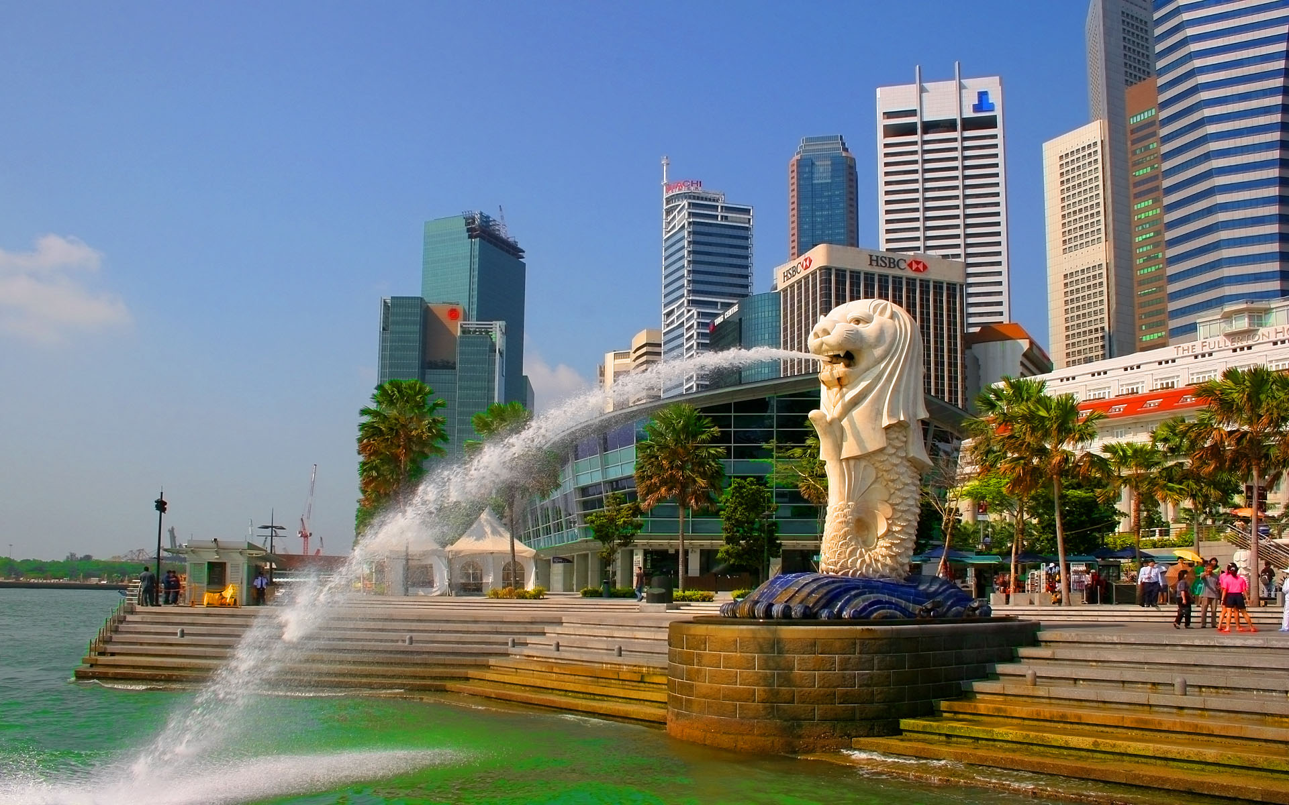](http://www.google.com/url?sa=i&rct=j&q=&esrc=s&source=images&cd=&cad=rja&uact=8&ved=2ahUKEwj2jLCw9afdAhWItI8KHRXdCXsQjRx6BAgBEAU&url=http%3A%2F%2Fviterbivoices.usc.edu%2Fmadelina%2Fmarching-forward-in-singapore%2F&psig=AOvVaw0JrXc3GJoKHSZtuhLksRxG&ust=1536376169498780)